31. Implement Lexical Analyzer using FLEX (Fast Lexical Analyzer). The program should separate the tokens in the given C program and display with appropriate caption.

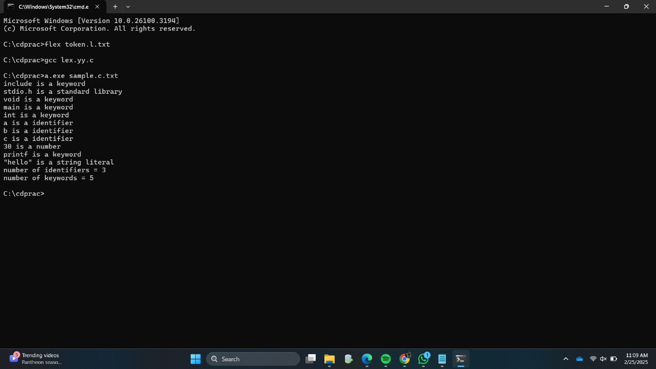

32. Write a LEX program to count the number of vowels in the given sentence.

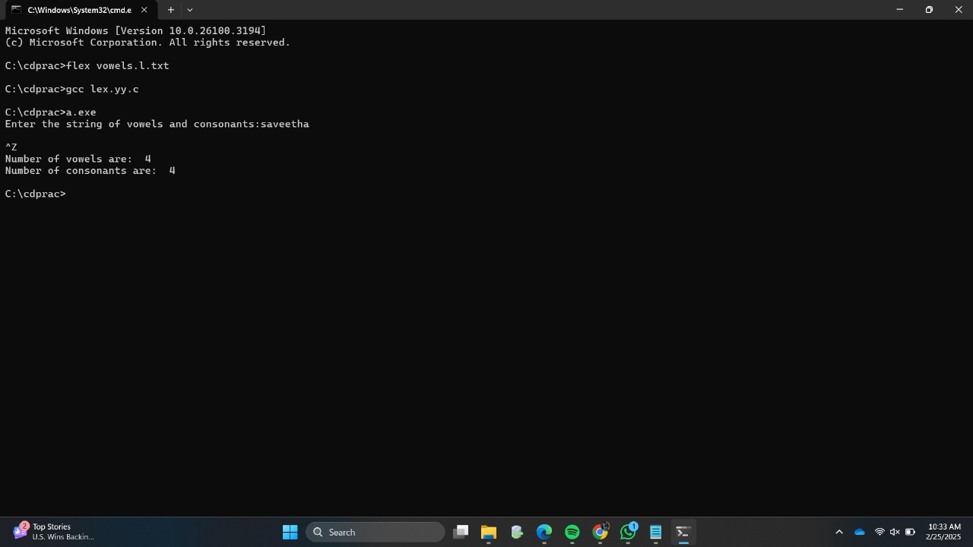

33. Write a LEX program to count the number of vowels in the given sentence.



34. Write a LEX program to separate the keywords and identifiers.



35. Write a LEX program to recognise numbers and words in a statement.

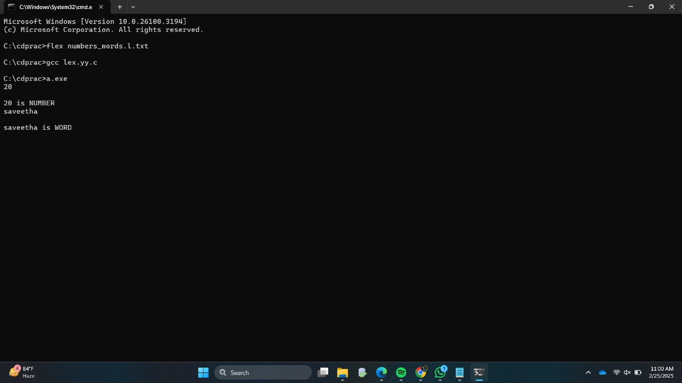

36. Write a LEX program to identify and count positive and negative numbers.

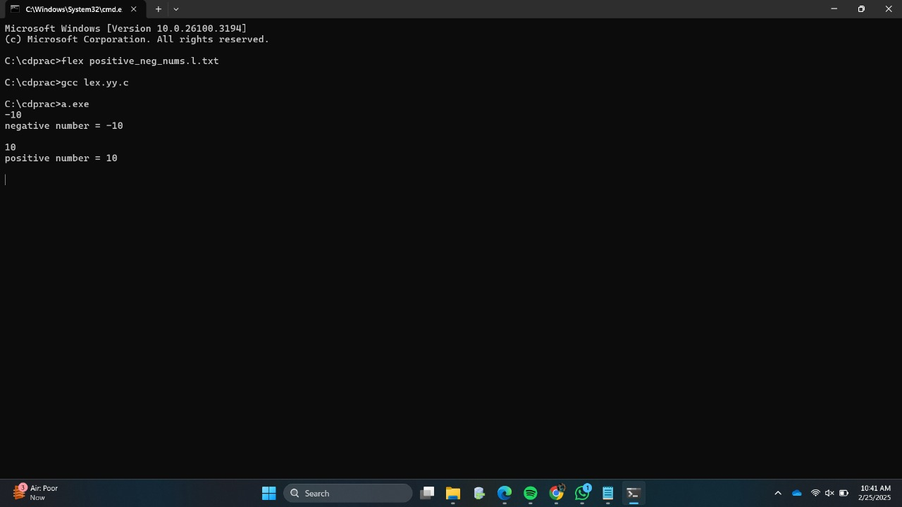

37. Write a LEX program to validate the URL.

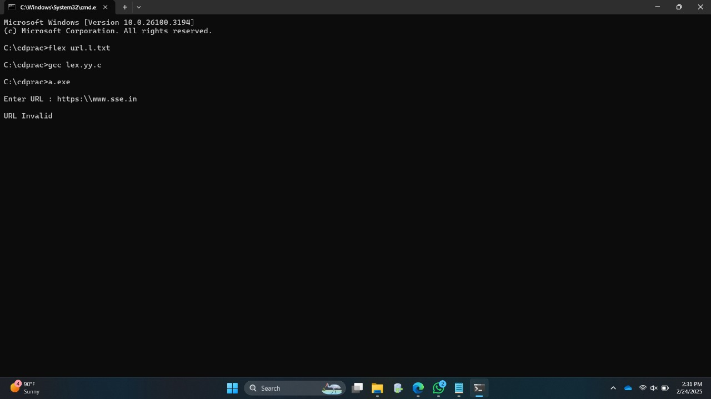

38. Write a LEX program to validate DOB of students.

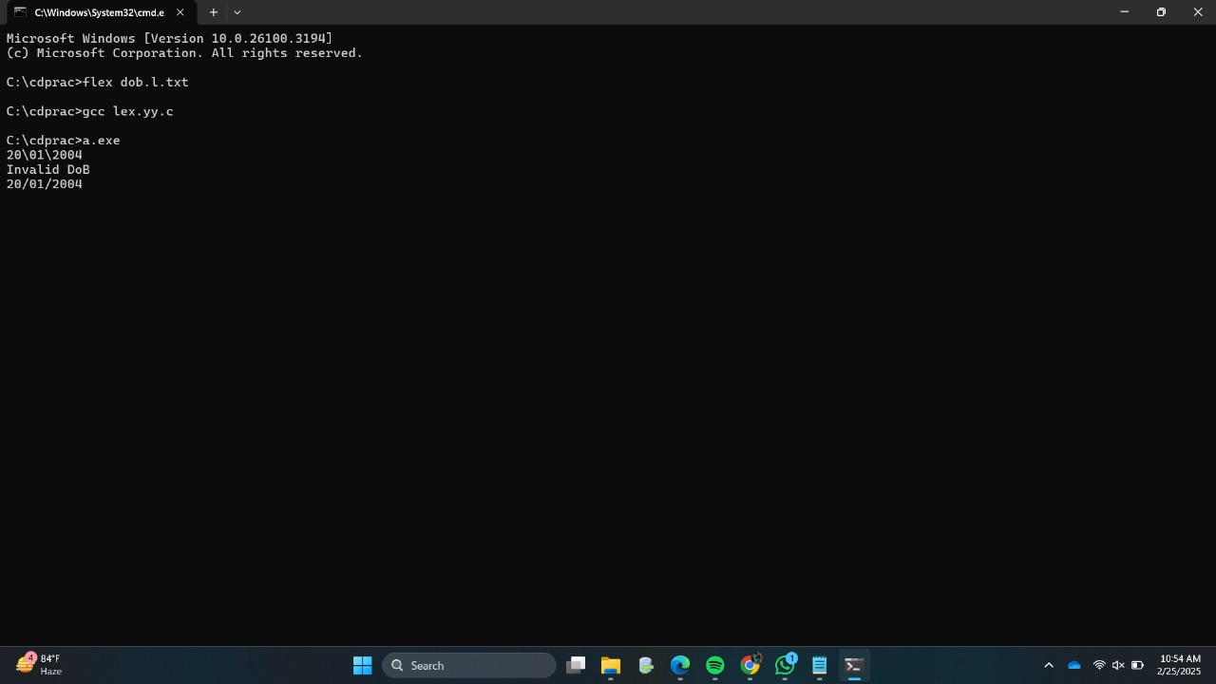

39. Write a LEX program to check whether the given input is digit or not.

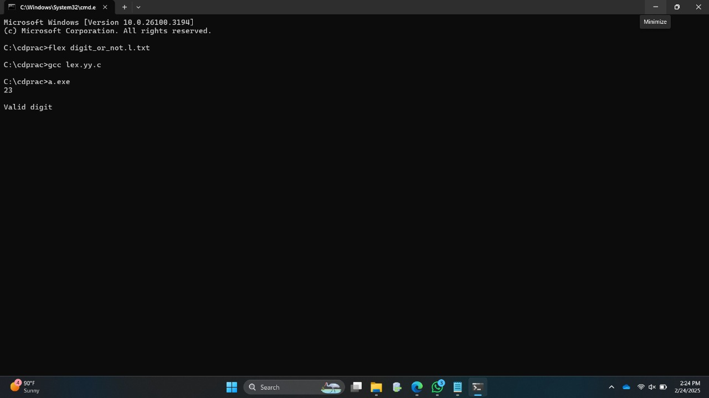

40. Write a LEX program to implement basic mathematical operations.

